Reincarnation-New Perspective from Jesus
December 12th, 2021

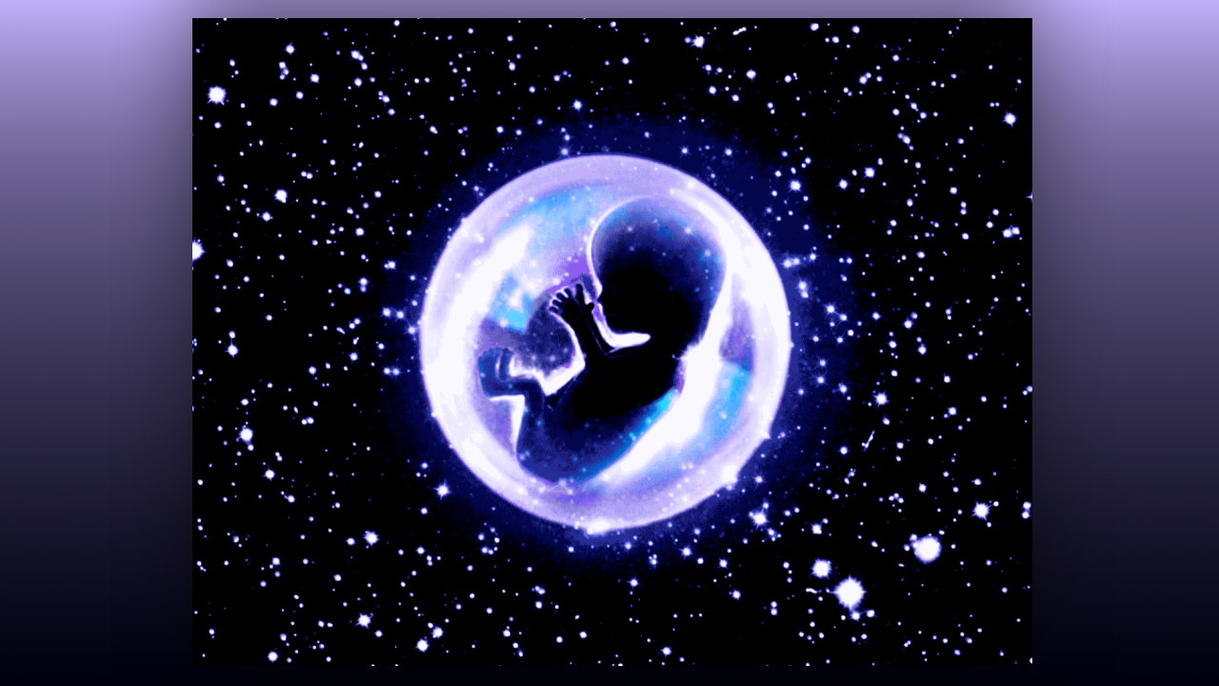
Lord Jesus, please reveal to us the secrets of the universe and which things are true. There are so many plausible explanations for so many things, but I am seeking only the truth. Please reveal truth to me in such a way that I can embrace it and find endless peace. Amen.

Lord, what do I say to those who believe in reincarnation? What is the truth? Have I been misled? Can you believe in reincarnation and still go to Heaven?

Jesus replied. He said, “Say to them, why would you want to be burdened with another life of drudgery? I did not design you to suffer through that again. I designed you to live in glory. Why in the world would you want to return to that? In the world I am providing for you, life will be lived in joy with all your needs met. Why would you choose to go back to Earth as a dog, or a slug, or a snail, if you could at last be free from corruption?

“My dear children, I came from Heaven to pay for your failures and redeem you. That means that your sins and failures are wiped clean if you are truly sorry. I weathered sickness, disease, violence, misunderstanding, cruelty and suffering to pay for your liberty.

” When you die in a state of grace, you are brought to Heaven with all your faults and ailments. Immediately you will see the River of Life flowing from the throne of My Father. Lining the sides of this beautiful sparkling pure water are trees which are in constant bloom and produce fruit for you to heal. I know what you have been through on the Earth, never do I want you to suffer that again. Never do I want you to live a toilsome life with all kinds of handicaps and diseases. No! I freed you from that by My passion.

“At last, you are home. But your souls are damaged from life in a fallen world. I was the perfect sacrifice for every time you fell. Now I want you to be fresh and perfect. Whatever your sickness, malady, sins, they were the result of that fallen world and your interaction with it to survive. Now I have much, much better things for you. You have passed the test, you have now entered Eternal Life, and as such you will eat the fruit and leaves of these trees to be restored to perfection. Your joy will have no boundaries at all.

“Even while you are on the banks of the river with others, drinking and eating the healing fruits, you will forget the ugliness of the past and what caused your body to deteriorate. As you let go of those memories, more and more healing grace will flood your soul and your body will be made perfect. Your mind, emotions, also will become perfect, you will have automatic access to all knowledge and questions will be answered before you even ask.

“You will be able to see everything that happened to you from Heaven’s perspective, and you will understand and be relieved of every “WHY” question you have ever asked yourself. DNA carries memories and an entire world of experience, and you will see into past generations, the ancestral history of your DNA, which has a strong bearing on what you became in this life, why you did things, why certain people were in your life, why some were failures and why some succeeded. In short you will have every answer to every question you have ever asked yourself and you will understand the dynamic of ancestry and what generational curses or blessings are passed down, as well as why some live a blessed life because their ancestors were good and holy.

“Nevertheless, you will be healed, whole and perfect in glory with Me. That is the very first thing that will happen to you. What will come after that is an environment of purity for you to do the things your heart has always desired to do. Why? Because I put those heart’s desires in you from birth. You were made equipped with skills to do everything in your heart.

“But this is a cruel, cruel world, because Satan also sees and assigns demons to lead you astray or make it impossible for you to fulfill the gifts you were born to flourish with, you are opposed in fulfilling your destiny. His motives are to rob you of your destiny and take your soul to Hell. That is what he lives for.

“Those of you who need to believe in reincarnation, you have no idea the gifts I have for you in Heaven. You think that you must earn your perfection by going through thousands of years of suffering. No! That is not how it works. I went through three days of suffering to pay for all your mistakes and release to you the fountain of life complete with healing herbs and fruit. Wouldn’t you rather get started with eternal life than have to suffer through Earth again??

“I am eternally grateful to you for choosing to live your life for Me, and because of that, I have gone to prepare a place for you. A place of wonder…if it is architecture you love, your home will be a dream house. If it is nature that you love, you will be in the pristine forests of Heaven. My servant, Jesse Duplantis marveled at his mansion in Heaven because it was decorated with costly renaissance masterpieces of furniture. That is what he loved and so that is what I procured for him. That was part of his reward. Mother Clare loves the wilderness, animals and nature and hers is a palace in the wilderness with seven waterfalls and a clear glass floor revealing where whales and dolphins play in the water. Behind each of the waterfalls is a different kind of terrain and climate, all of them dream places for her. She has a snowy owl she has always wanted, a young cougar, playful and loving, a polar bear and a white tiger. In addition, all her former animals that went on before her will greet her when she arrives and everything she has ever loved will be built into this palace.”

Ok. Well, here I just want to insert that if you read Chronicles of the Bride, which is a book that Ezekiel and I wrote, you will see what the Lord has prepared for me in Heaven, and how unworthy I am. The first night He took me there, I was speechless. When he brought me back to my earthly body, I wandered around for a whole week in a daze. I know my failures, and I know I did not deserve all that! But yet He wanted me to have it. Do you think I want to return to Earth? Well to help others, sure would not want to live through it again.

But dear ones, I was just blown away by every detail, the things He created for me in Heaven in my little mansion. Just blown away. The colors, the shapes, the qualities, the properties, everything, everything is just like a dream come true.

Nothing happens by accident my dear family and tonight, I took a short break with my husband after dinner, and we watched Johnathan Kahn. He began by talking about a baby in a womb. The child has feet but nowhere to walk yet, has hands but nothing to do with them yet, eyes but nothing to see, ears but nothing to hear…he said that to illustrate something, Earth is the Womb of Heaven. When we complete this life on Earth, then we will go to Heaven, just as a child who comes out of the womb and on to this Earth now has a place to walk, things to touch, eyes to see and ears to hear.

Earth is where we prove our fidelity to God and gain Heaven. Earth is like a confining womb; we cannot really go and do what we want to accomplish or attain anything worthwhile until we leave our mother’s womb. Even so, when we leave Earth then the fullness of what we were created to be and do will be ours.

“People want another chance to improve and make up for their mistakes, to prove themselves, to wipe the slate clean. But what they do not realize is that new and worse challenges and events will take place if they were to go back to Earth and try and do it all over again. There will still be pain, disappointment, failure, sickness, and loss. I have paid the price for all of those things the very first time around when you were born, grew up became old and died. I paid for every mistake you made, everything. Now I want you to enjoy My unconditional love and provision for a holy life, full of all the things and skills you need, full of authentic friends who completely accept, love, and understand you. Full of teachers to help you master the skills you dreamt of having. Everything you have ever dreamt of has been prepared for you in Heaven.

“Why would you want to return to Earth when you had this as your guaranteed eternity?

“I am sorry to disappoint you, but I am not sending you to that place to suffer, ever again. Rather I am preparing your homeland where everything you ever needed or wanted is yours. You will be very busy, creating, guiding, building, playing musical instruments, exploring, writing songs, writing books, swimming, mountain climbing, loving on your favorite wild animals, living in your own home or living in a beautiful garden apartment next to people you love. Or you will be cooking in the kitchens of Heaven the meals you love to make and sharing them with your brothers and sisters. You will go swimming with dolphins, skating with polar bears, flying from forest to forest or mountain top to lush valleys with flowers that turn their heads and follow you and sing. Everything will greet you with love, the bees will allow you to taste their honey and form a heart in front of your very eyes to salute you, the fish and animals will come to you for attention, and angels will meet your needs. You will be with Me exploring the outer reaches of Heaven and flying above everything at will with only your body and a desire to fly.

“You will never be tired or sick, although you will at times rest and need a time of inactivity. You will be helping friends and children still on the earth to attain to Heaven, praying for them, and the relatives that you left behind. You will be allowed to even visit them in dreams. Now this is what I do for those who love Me. I would never send them back to Earth to be perfected by more trials, never.

“So, you see, you have been lied to. Just because certain people groups have mastery over their flesh and can-do extraordinary things does not mean that they know the very truth of God and who I AM. They know the rules that matter, but that does not guarantee that they know Me. They know how to control their flesh to do amazing things because they know the dynamics, but they do not know the truth about Me. I am not some far off energy, impersonal God or mist or force. I am and your best friend, I am your lover, I am your spouse, your father, your everything. I will supply all your needs because you are My child and I love you to distraction. I want you to be whole and healed, I want to hear squeals of delight when you see what I have made, just for you.

“I want to go on picnics and the beach, visit the lions and giraffes with you, fly around paradise islands with you, swing in a hammock with you, spend time just being in your presence and delighting Myself in your wonder and surprise. You will see how much I love you. You will see that everything I have said here is true. With all this at your disposal after one lifetime, why would you want to return to a corrupted Earth to start all over again? Why? I have just paid your ransom and nothing more is needed to square off your debt. It is finished.

“Now I want to gaze into your eyes, hold your precious hand in Mine and see happiness overtake you with unspeakable joy, forever and ever. And if you want to return to the new Earth to help teach souls, we will do that together as well. But I will never again put you at the mercy of a brutal and corrupt world. Never. You have graduated, and you are Mine. You have left the womb that is Earth and now you are going to walk the golden streets, swim in the crystalline coves and find joy with all those you love.

“Beloved ones, this is My final word to you on this topic. Reincarnation is a lie; Heaven is your next destination and I have gone ahead of you to prepare that place with all your favorite things. No need to worry, this painful life is something you will never have to repeat, you will never be at the mercy of, and never have to live through again. And this I have done for you because I truly love you. You will see Me soon.”

